**TITLE**

Company Analysis Report submitted in partial fulfillment of the requirements for

the award of the Degree of

**BACHELOR OF COMMERCE**

**Of**

**DAVANGERE UNIVERSITY**

*By*

SAHANA H L

Reg. No U13BH21C0001

**UNDER THE GUIDANCE OF**

**SHWEETA B V**

**ASSISTANT PROFESSOR**

**BIHE, DAVANGERE**



**BAPUJI INSTITUTE OF HI-TECH EDUCATION**

**DAVANGERE- 577004**

**2020-2023**

**TITLE**

Company Analysis Report submitted in partial fulfillment of the requirements for

the award of the Degree of

**BACHELOR OF COMMERCE**

**Of**

**DAVANGERE UNIVERSITY**

*By*

SAHANA H L

Reg. No U13BH21COOO1

**UNDER THE GUIDANCE OF**

**SHWEETA BV**

**ASSISTANT PROFESSOR**

**BIHE, DAVANGERE**



**BAPUJI INSTITUTE OF HI-TECH EDUCATION**

**DAVANGERE- 577004**

**2020-2023**

**DECLARATION**

I hereby declare that the Company Analysis Report entitled “ SAHANA H L” submitted to Bapuji Institute of Hi-Tech Education, Department of Commerce, Davangere, is a record of an original work done by me under the guidance of SHWEETA B V, ASSINTANT PROFESOR, Bapuji Institute of Hi-Tech Education, Department of Commerce, Davangere and this Company Analysis Report is submitted in the partial fulfilment of the requirements for the award Bachelor Degree in Commerce by Davangere University.

I also declare that this report is the outcome of my own efforts and that it has nSAHANAot been submitted to any other university or Institute for the award of any other degree or Diploma or Certificate.

Place: Davangere Signature of student

Date: Name: SAHANA H L

U13BH21C0001

**ACKNOWLEDGEMENT**

I am using this opportunity to express my gratitude to everyone who supported me throughout the Company Analysis. I express my sincere thanks to Dr. Swamy Tribhuvananda H V, Director, Bapuji B-Schools, Davanagere. I would like to thank to Dr. B Veerappa, Principal, Bapuji Institute of Hi-Tech Education, Davanagere. I sincerely express deep sense of gratitude and appreciation to my internal guide SUBBRMANYA, Assist ant Professor, Bapuji Institute of Hi-Tech Education, Department of Commerce, for his careful and valuable guidance, never ending patience and constant encouragement throughout the Company Analysis. Lastly, I would like to thank my parents and friends for extending their support in completing the Company Analysis Report.

**Date:**

**Place : Davanagere SAHANA H L**

**U13BH21C0001**

|  |
| --- |
| CONTENTS |
| Chapter No. INDEX Page No. |

|  |  |  |
| --- | --- | --- |
| 1 | Introduction   * 1. Overview of the company   2. Inception of the company   3. Nature of the business   4. Mission   5. Vision   6. Goals   7. Objectives   8. Quality policy   9. Product/Service profile   10. Area of operating   11. Ownership pattern   12. Competitors information   13. Infrastructural facilities   14. Achivementalawards   15. Strategic perspective plan | 1-17 |
| 2 | Financial and Market Analysis  2.1 Financial Analysis  2.1.1 Statement of Profit or Loss  2.1.2 Statement of Financial Position  2.1.3 Statement of Cash Flow  2.1.4 Financial Ratios  2.1.5 Company’s financial health  2.2 Market Analysis  2.2.1 Company’s Position Within its Industry  2.2.2 Market Trends  2.2.3 Competition  2.2.4 Potential Growth Opportunities | 17-23 |
| 3 | Management and Market Analysis  3.1 Leadership Team and their Qualifications  3.2 Corporation Governance and Decision- Making Process | 24 30 |
| 4 | SWOT analysis  4.1 SWOT analysis  4.2 McKinsey 7S model | 30-32 |
| 5 | Suggestion and conclusion  5.1 Summary of findings, suggestions and conclusion  5.2 Recommendation  5.3 Overall Outlook for the company | 33 |
| 6 | Learning Experience | 34 |
| 7 | Bibliography (Format- Appendix X) | 35 |

**CHAPTER 1**

**1.1 Introduction**•

Domino’s is an American multinational pizza restaurant chain. Founded in 1960, the Chain is owned by Master. Franchiser Domino’s Pizza Inc and led by CEO Russell Weiner. Headquarters is in the Domino’s Farm Houses Park in an Arbour Township near an ArbourMichigan as on 2018 Dominos had approximately. 15000 stores with 5649. In the United States, 1500 in India and 1249 in , United Kingdom, Dominos has stores in over. 83 countries, 5701 Cities.

Domino's is a well-known global pizza delivery and takeout restaurant chain, renowned for its delicious pizzas and commitment to efficient delivery service. Founded in 1960 in Ypsilanti, Michigan, by Tom Monaghan and his brother, James, the company has since grown into one of the world's largest and most recognized pizza chains. Domino's success is built on its dedication to delivering hot and fresh pizzas directly to customers' doors. Over the years, it has expanded its menu to offer a wide variety of pizza options, from classic favorites to innovative creations, along with other delectable items like pasta, chicken dishes, sandwiches, and mouthwatering desserts. One of Domino's distinctive features has been its continuous embrace of technology to enhance the ordering and delivery experience. Through a user-friendly online and mobile ordering platform, customers can effortlessly customize their pizzas and place orders for speedy delivery or convenient pickup. This commitment to innovation has made Domino's a pioneer in the pizza industry. As a publicly traded company listed on the New York Stock Exchange, Domino's has a global presence, with thousands of stores operating in more than 90 countries. primarily operates under a franchise model, with dedicated franchisees owning and operating the majority of its outlets. This approach has facilitated its rapid growth and widespread reach. With a focus on quality, convenience, and customer satisfaction, Domino's continues to be a favorite choice for pizza lovers worldwide. Please note that while this introduction provides an overview of Domino's, the company's specific offerings and strategies may evolve over time, so it's advisable to check the latest information for the most up-to-date details about Domino's operations.

**1.2 Brief Overview Of The Company**

**Founding**: Domino's was founded in 1960 by Tom Monaghan and his brother, James, in Ypsilanti, Michigan, USA. Initially, it was called "DomiNick's," but the name was later changed to Domino's Pizza.

**Pizza Delivery Focus:** Domino's is best known for its focus on pizza delivery and takeout. It pioneered the 30-minute pizza delivery guarantee in the 1980s, although this guarantee was later discontinued due to safety concerns.

**Global Presence**: Domino's has expanded its operations globally and is one of the world's largest pizza chains. As of my last knowledge update in September 2021, it had over 17,000 stores in more than 90 countries.

**Menu:** While pizza is the core offering, Domino's has diversified its menu to include a variety of pizza styles, pasta, chicken dishes, sandwiches, and desserts.

**Digital Innovation:** Domino's has been a leader in leveraging technology for ordering and delivery. The company developed a robust online and mobile ordering platform, allowing customers to place orders easily. They have also experimented with delivery robots and autonomous vehicles.

**Stock Exchange Listing:** Domino's is a publicly traded company, and its stock is listed on the New York Stock Exchange under the ticker symbol "DPZ."

**Franchise Model:** Domino's primarily operates on a franchise model, with franchisees owning and operating the majority of its stores. This model has contributed to its rapid global expansion

**Corporate Social Responsibility:** The company has engaged in various corporate social responsibility initiatives, including efforts to reduce its environmental impact and support local communities.

**Inspection Of Domino’s Company**

**1. Financial Performance:**

Revenue and Profitability: Review the company's recent financial statements to assess its revenue growth, profitability, and trends over the past few years.

Cost Structure: Analyze the company's cost structure, including expenses related to ingredients, labor, and advertising.

Debt and Liquidity: Evaluate the company's debt levels, if any, and its ability to meet short-term financial obligations.

**2. Market Position:**

Market Share: Examine the company's market share in the global pizza delivery industry and its competitive positioning.

Customer Base: Assess the company's customer demographics and loyalty programs.

**3. Operational Efficiency:**

Supply Chain Management: Evaluate the efficiency of Domino's supply chain, which is crucial for ensuring the timely delivery of products.

Technology and Innovation: Analyze the company's technological innovations, such as online ordering systems, delivery tracking, and any AI-driven initiatives.

**4. Menu and Product Offerings:**

Menu Diversity: Review the menu to understand the range of offerings, including different pizza types, sides, and desserts.

Product Quality: Assess the quality and consistency of Domino's food products.

**5. Franchise Model:**

Franchisee Relationships: Examine the company's relationships with franchisees, their satisfaction, and support provided by the franchisor.

Franchise Expansion: Evaluate the company's franchise expansion strategy and its impact on growth.

Competitive Risks**: Analyze threats posed by competitors and the fast-food industry as a whole.

**1.3 Nature Of Business Carried In Domino’s**

**1. Pizza Production and Delivery:** Domino's specializes in the production and delivery of a wide variety of pizzas, including traditional and specialty options. The company's core competency lies in preparing, baking, and delivering pizzas to customers' homes and businesses.

**2. Menu Diversification:** While pizza is the mainstay of Domino's menu, the company has expanded its offerings to include various pizza styles, such as hand-tossed, pan, thin-crust, and stuffed crust pizzas. In addition to pizza, they offer pasta dishes, chicken items, sandwiches, side items like breadsticks and chicken wings, and desserts.

**3. Online and Mobile Ordering:** Domino's has invested significantly in technology to facilitate online and mobile ordering. Customers can place orders through the company's website or mobile app, customizing their pizza and tracking its delivery in real-time.

**4. Franchise Model:** Domino's operates primarily as a franchise business. It grants franchisees the rights to operate Domino's restaurants under its brand name and provides them with training, support, and access to its supply chain. Franchisees own and manage individual stores, while the company collects fees and royalties.

**5. Global Expansion:** Domino's has a global presence with thousands of stores in over 90 countries. It actively seeks opportunities to expand its footprint into new markets and regions

**6. Marketing and Branding:** The company places a strong emphasis on marketing and advertising to promote its brand. Domino's has run numerous marketing campaigns over the years to highlight its products, delivery speed, and customer satisfaction.

**7. Digital Innovation:** Domino's is known for its innovative use of technology, including initiatives like the "Pizza Tracker" for real-time order tracking and experiments with autonomous delivery vehicles and drones.

**8. Customer Experience:** Providing a positive customer experience, from ordering to delivery or pickup, is a key aspect of Domino's business. Timely and efficient delivery is a priority.

**9. Corporate Social Responsibility:** Domino's engages in various corporate social responsibility initiatives, such as sustainability efforts, charitable giving, and community involvement.

**1.4 Missions Of Domino’s**

‘’Domino’s pizza is the pizza specialist who consistently delight the customer with customer taste and choices in pizza with friendly courteous team members providing prompt , safe delivery service ‘’

***1.5 Goals and Objectives:***

**1. Revenue Growth:** One of the primary objectives for Domino's may be to achieve consistent revenue growth year-over-year, both through same-store sales increases and new store openings.

**2. Customer Satisfaction:** Ensuring high levels of customer satisfaction and loyalty by consistently delivering quality products, excellent service, and an exceptional customer experience.

**3. Global Expansion:** Expanding its global footprint by entering new markets and increasing market share in existing ones.

**4. Franchisee Support:** Providing comprehensive support and resources to franchisees to help them succeed and grow their businesses.

**5. Digital Innovation:** Continuously investing in technology and digital innovations to streamline operations, improve customer ordering experiences, and enhance delivery efficiency.

**6. Sustainability:** Implementing sustainability initiatives to reduce the environmental impact of its operations, such as reducing waste and energy consumption.

**7. Employee Development:** Fostering a positive and inclusive workplace culture, promoting employee development and advancement, and ensuring employee safety.

**Quality Policy**

Domino's quality policy would likely emphasize the following:

**1. Food Quality:** Commitment to using fresh, high-quality ingredients in all menu items, ensuring consistency and taste in every pizza delivered.

**2. Safety and Hygiene:** Maintaining strict food safety and hygiene standards in all aspects of food preparation, handling, and delivery.

**3. Customer Satisfaction:** Ensuring that customer orders are accurate, delivered promptly, and meet or exceed customer expectations.

**4. Franchisee and Employee Training:** Providing comprehensive training and ongoing support to franchisees and employees to uphold quality and service standards.

**5. Continuous Improvement:** Encouraging a culture of continuous improvement in all processes, from sourcing ingredients to delivery logistics.

**6. Environmental Responsibility:** Implementing sustainable practices to minimize environmental impact, such as recycling, waste reduction, and energy-efficient operations.

**1.6 Vision of Domino’s**

Expectational people on a mission to be the best pizza delivery company in the world

Global Operations in Domino’s

**1. International Presence:** Domino's had a strong international presence with thousands of stores operating in more than 90 countries. The company's international expansion had been a key part of its growth strategy.

**2. Franchise Model:** Domino's primarily operates under a franchise model globally. This means that the majority of its stores outside of the United States are owned and operated by independent franchisees. These franchisees are responsible for running their stores according to Domino's standards and guidelines.

**3. Regional Variations:** Domino's adapts its menu and offerings to cater to local tastes and preferences in various countries. This may include creating unique pizza flavors or offering regional specialties to appeal to local customers.

**4. Global Marketing:** While Domino's maintains a consistent brand image globally, it often tailors its marketing campaigns to suit local markets and cultures. This approach helps to connect with customers on a regional level.

**5. Digital Ordering:** The company's emphasis on technology and digital innovation extends to its international operations. Domino's offers online and mobile ordering platforms in many countries to make it convenient for customers to place orders.

**6. Global Delivery Network:** Domino's has a well-established global delivery network, which includes a fleet of delivery drivers and efficient logistics systems to ensure timely and reliable delivery service worldwide.

**7. Market Expansion:** Domino's continued to explore opportunities for market expansion in countries where it had a presence, as well as entering new markets. Expanding into emerging markets has been a significant focus for the company.

**8. Local Partnerships:** In some countries, Domino's forms partnerships with local businesses or investors to facilitate market entry and growth. These partnerships often involve joint ventures or master franchise agreements.

**9. Cultural Sensitivity:** Domino's is attentive to cultural sensitivities and dietary preferences in various regions, ensuring that its menu offerings align with local customs and restrictions**.**

**National Operations In Domino’s**

Domino's Pizza, Inc. operates its national operations in the United States, where it is headquartered. Here is an overview of Domino's national operations in the United States:

**1. Company-Owned and Franchised Stores:** In the United States, Domino's operates a combination of company-owned stores and franchised stores. Company-owned stores are directly owned and operated by the corporate entity, while franchised stores are owned and operated by independent franchisees.

**2. Franchise Model:** Similar to its global operations, Domino's national operations in the U.S. primarily operate under a franchise model. Independent franchisees own and run the majority of Domino's stores across the country.

**3. Menu Offerings:** Domino's offers a diverse menu in the U.S., including a variety of pizza styles, pasta dishes, chicken items, sandwiches, sides such as breadsticks and chicken wings, and desserts. The menu may vary slightly based on regional preferences.

**4. Online and Mobile Ordering:** Domino's places a strong emphasis on online and mobile ordering in the U.S. Customers can easily place orders through the official Domino's website or mobile app, customizing their pizzas and tracking their deliveries in real-time.

**5. Delivery and Carryout:** Domino's provides both delivery and carryout services in the U.S. Customers can choose to have their orders delivered to their homes or opt for carryout by picking up their orders from the nearest Domino's store.

**6. Digital Innovation:** The company's digital innovations, such as the "Pizza Tracker" and various online ordering features, are available to customers in the U.S. These innovations enhance the ordering experience and provide real-time updates.

**7. Marketing and Advertising:** Domino's conducts marketing and advertising campaigns tailored to the U.S. market to promote its products and services. These campaigns often focus on pizza quality, delivery speed, and customer satisfaction.

**8. Community Involvement:** Domino's is involved in community engagement and charitable initiatives in the United States to give back to local communities where it operates.

**9. Environmental Initiatives:** The company may have implemented environmental initiatives in the U.S. to reduce its environmental impact, such as recycling programs and energy-efficient practices.

**10. Employee Training and Development:** Domino's provides training and development opportunities for its employees in the United States, focusing on delivering high-quality service and maintaining food safety standards.

**Regional Operations In Domino’s**

Domino's regional operations can vary significantly based on the specific region or country in which the company operates. While the core elements of Domino's service profile and business model remain consistent, there are often adaptations and variations to cater to regional tastes, preferences, and market conditions. Here are some key considerations for Domino's regional operations:

**1. Menu Customization:** Domino's often customizes its menu to suit regional tastes and preferences. This can include offering unique pizza flavors or incorporating local ingredients and specialties into the menu.

**2. Cultural Sensitivity:** Domino's is attentive to cultural sensitivities and dietary preferences in different regions. For example, in regions with specific dietary restrictions or cultural preferences, the menu may be adapted to accommodate those needs.

**3. Marketing and Branding:** While Domino's maintains a consistent global brand image, it may tailor its marketing campaigns and branding efforts to resonate with the local culture and market dynamics.

**4. Supply Chain Localization:** In some regions, Domino's may establish local supply chains to ensure the availability of fresh ingredients and reduce logistical challenges.

to compete effectively with local and international competitors.

***1.7 Values of Domino’s***

**1. Putting the Customer First:** Domino's places the customer at the center of everything it does. This value underscores the importance of customer satisfaction, quality service, and meeting customer preferences.

**2. Continuous Improvement:** Domino's is committed to a culture of continuous improvement. This value drives the company to constantly seek ways to enhance its products, processes, and services.

**3. Innovation:** The company values innovation and technology, particularly in the realm of digital technology and delivery systems. Domino's strives to be at the forefront of technological advancements in the fast-food industry.

**4. Integrity:** Integrity is a fundamental value for Domino's, emphasizing honesty, transparency, and ethical behavior in all aspects of its business.

**5. Teamwork:** Domino's believes in the power of teamwork and collaboration. The company values the contributions of its employees, franchisees, and partners in achieving its goals.

**6. Quality:** Domino's is dedicated to providing high-quality food products made with fresh and carefully sourced ingredients. This commitment to quality extends to its pizza and all menu offerings.

**7. Community Engagement:** The company values its role within the communities in which it operates. Domino's is involved in charitable initiatives and community engagement efforts to give back and make a positive impact.

**8. Environmental Responsibility:** Domino's acknowledges its environmental responsibilities and is committed to sustainability initiatives aimed at reducing its carbon footprint and minimizing waste.

**1.8 Ownership Pattern In Domino’s**

**1. Company-Owned Stores:** Domino's owns and operates a portion of its stores directly. These are referred to as company-owned stores. In these locations, Domino's has full control over operations, management, and quality standards.

**2. Franchise-Owned Stores:** The majority of Domino's stores, both in the United States and internationally, are owned and operated by independent entrepreneurs and investors who have obtained franchise agreements from Domino's. These franchisees are responsible for the day-to-day operations of their stores, including staffing, customer service, and adherence to Domino's operational and quality standards.

**3. Master Franchise Agreements:** In some countries or regions, Domino's may establish master franchise agreements. Under such agreements, a master franchisee is granted the exclusive rights to develop and sub-franchise Domino's stores within a specified geographic area or country. The master franchisee is responsible for recruiting and supporting sub-franchisees within their territory.

**4. Joint Ventures and Partnerships:** Domino's may also enter into joint ventures or partnerships with local businesses or investors to facilitate market entry and expansion in specific regions. These arrangements can involve shared ownership and decision-making.

**5. Ownership Mix:** The precise mix of company-owned and franchised stores can vary by region and market conditions. Domino's often maintains a balance between company-owned and franchised locations to ensure both operational control and opportunities for franchisees.

**Competitor Information In Domino’s**

**1. Pizza Hut:** Pizza Hut is one of the largest and most well-known pizza chains globally. It offers a wide range of pizza styles, pasta dishes, and other fast-food items.

**2. Papa John's:** Papa John's is another major pizza chain known for its emphasis on high-quality ingredients and "Better Ingredients, Better Pizza" slogan.

**3. Little Caesars:** Little Caesars is known for its affordability and convenience, offering "Hot-N-Ready" pizzas that are available for immediate pickup without ordering in advance.

**4. Domestic and Regional Chains:** In addition to national chains, Domino's competes with various regional and local pizza chains in different markets. These chains often cater to specific regional tastes and preferences.

**5. Fast-Food Chains:** Domino's also competes with fast-food chains that offer a variety of menu items, including pizza, such as McDonald's and Burger King.

**6. Online Food Delivery Platforms:** With the rise of online food delivery services like Uber Eats, Grubhub, and DoorDash, Domino's competes with these platforms for online orders and delivery services.

**7. Grocery Stores:** In some regions, Domino's competes with grocery stores that offer pre-made or frozen pizzas for purchase.

**8. Independent Pizzerias:** Independent pizzerias and local pizza shops are also competitors for Domino's, as they often emphasize unique, homemade recipes and personalized service.

**1.9 Infrastructural Facilities In Domino’s**

**1. Store Locations:** Domino's has a network of store locations, both company-owned and franchised, spread across various regions and markets. These stores serve as the primary points of contact with customers for order placement, preparation, and delivery or carryout.

**2. Commercial Kitchens:** Within each store, there are commercial kitchens equipped with ovens, prep stations, storage areas, and all the necessary equipment for making pizzas and other menu items. The kitchens are designed to efficiently prepare and cook orders.

**3. Delivery Vehicles:** Domino's maintains a fleet of delivery vehicles, including cars, scooters, and bikes, for the purpose of delivering orders to customers' locations. These vehicles are often branded with the Domino's logo.moon

**4. Online Ordering Platforms:** Domino's invests in digital infrastructure, including websites and mobile apps, to facilitate online and mobile ordering. These platforms allow customers to place orders, customize pizzas, and track deliveries.

**5. Inventory and Supply Chain:** Domino's requires facilities for storing and managing inventory, including ingredients like dough, cheese, sauces, and toppings. Supply chain facilities are critical to ensuring a steady flow of fresh ingredients to stores.

**6. Training Centers:** Domino's often has training centers or facilities where franchisees and employees receive training on food preparation, customer service, and operational procedures. These facilities ensure consistency in quality and service across locations.

**7. Technology Infrastructure:** To support its digital initiatives and innovations, Domino's invests in technology infrastructure, including servers, data centers, and software systems for online ordering, delivery tracking, and more.

**8. Call Centers:** Some Domino's locations may have call centers or customer support centers dedicated to handling phone orders, customer inquiries, and feedback.

**9. Storage and Warehousing:** Domino's may have storage and warehousing facilities to stock non-perishable inventory items and packaging materials.

**10. Corporate Offices:** At the corporate level, Domino's maintains administrative offices to oversee business operations, marketing, finance, legal, and other corporate functions.

**11. Quality Control Facilities:** Domino's may have quality control facilities or laboratories for testing ingredients and ensuring that they meet the company's quality standards.

**12. Environmental Initiatives:** Some Domino's locations may invest in facilities and equipment to support environmental sustainability initiatives, such as waste recycling and energy-efficient practices.

**13. Community and Training Centers:** Domino's may have facilities dedicated to community engagement, charitable activities, and employee training and development.

**Achievement Awards In Domino’s**

Domino's Pizza, Inc. and its franchisees have received various awards and recognition over the years for their achievements and contributions to the fast-food and pizza industry. These awards often acknowledge excellence in areas such as business performance, customer service, marketing, and innovation. While the specific awards and achievements can vary from year to year, here are some examples of the types of awards and recognition that Domino's has received in the past.

LAS VEGAS,May 12 ,2002 The largest pizza company in the world

**1. Sales and Revenue Achievements:** Domino's has received awards for achieving high sales volumes and revenue growth, both nationally and internationally. These awards may recognize the company's ability to generate substantial revenue within the fast-food industry.

**2. Customer Satisfaction:** Awards related to customer satisfaction and service excellence are common. Domino's has been recognized for its efforts to provide a positive customer experience, including timely delivery and quality service.

**3. Marketing and Advertising:** Domino's has won awards for its innovative and effective marketing and advertising campaigns. These awards acknowledge the company's ability to create compelling and memorable marketing materials.

**4. Digital Innovation:** Domino's has received recognition for its advancements in digital technology and online ordering platforms. Awards may highlight the company's commitment to technological innovation and customer convenience.

**5. Franchisee Excellence:** Domino's often honors outstanding franchisees who have demonstrated exceptional performance and commitment to the brand. These awards may recognize factors like store operations, growth, and community involvement.

**6. Food Quality and Innovation:** Awards related to food quality, menu innovation, and product development can showcase Domino's dedication to providing high-quality and diverse menu options.

**7. Environmental and Sustainability Initiatives:** Domino's has received awards for its sustainability efforts and initiatives to reduce its environmental impact. These awards recognize responsible business practices.

**8. Community Involvement and Philanthropy:** Awards for community involvement and philanthropic efforts highlight Domino's contributions to charitable causes and community development.

**9. Employee Engagement and Development:** Domino's may be recognized for its commitment to employee training, development, and a positive workplace culture.

**10. Industry Rankings:** Domino's has often been ranked among the top pizza and fast-food chains in various industry publications and surveys.

**1.10 Strategic Perspective Plan In Domino’s**

Domino's Pizza, like any large and successful corporation, likely has a strategic perspective plan that guides its long-term vision, goals, and objectives. While the specific details of Domino's strategic plan may not be publicly disclosed, I can provide you with a general framework of what a strategic perspective plan for a company like Domino's might encompass:

**1. Mission and Vision:** The plan would start with a clear mission statement that outlines the company's purpose and a vision statement that defines its long-term aspirations. These statements set the overall direction for the company.

**2. SWOT Analysis:** Domino's would likely conduct a thorough analysis of its Strengths, Weaknesses, Opportunities, and Threats (SWOT) to identify internal and external factors that could impact its business.

**3. Market Analysis:** The plan would include a comprehensive analysis of the fast-food and pizza industry, including market trends, customer preferences, and competitive landscape.

**4. Objectives and Goals:** Domino's would set specific, measurable, achievable, relevant, and time-bound (SMART) objectives and goals. These could include financial targets, market share goals, and customer satisfaction benchmarks.

5. **Franchise Development:** Domino's franchise model would be considered, with strategies for recruiting, training, and supporting franchisees to ensure consistent brand standards.

**6. Innovation and Product Development:** Strategies for menu innovation, new product development, and staying ahead of changing customer preferences would be included.

**17. Sustainability and Social Responsibility:** The plan may address environmental sustainability initiatives, ethical business practices, and community engagement efforts.

**CHAPTER 2**

**2.1 Financial and market analysis**

Statement of balance sheet of domino’s pizza company of financial year of 2022

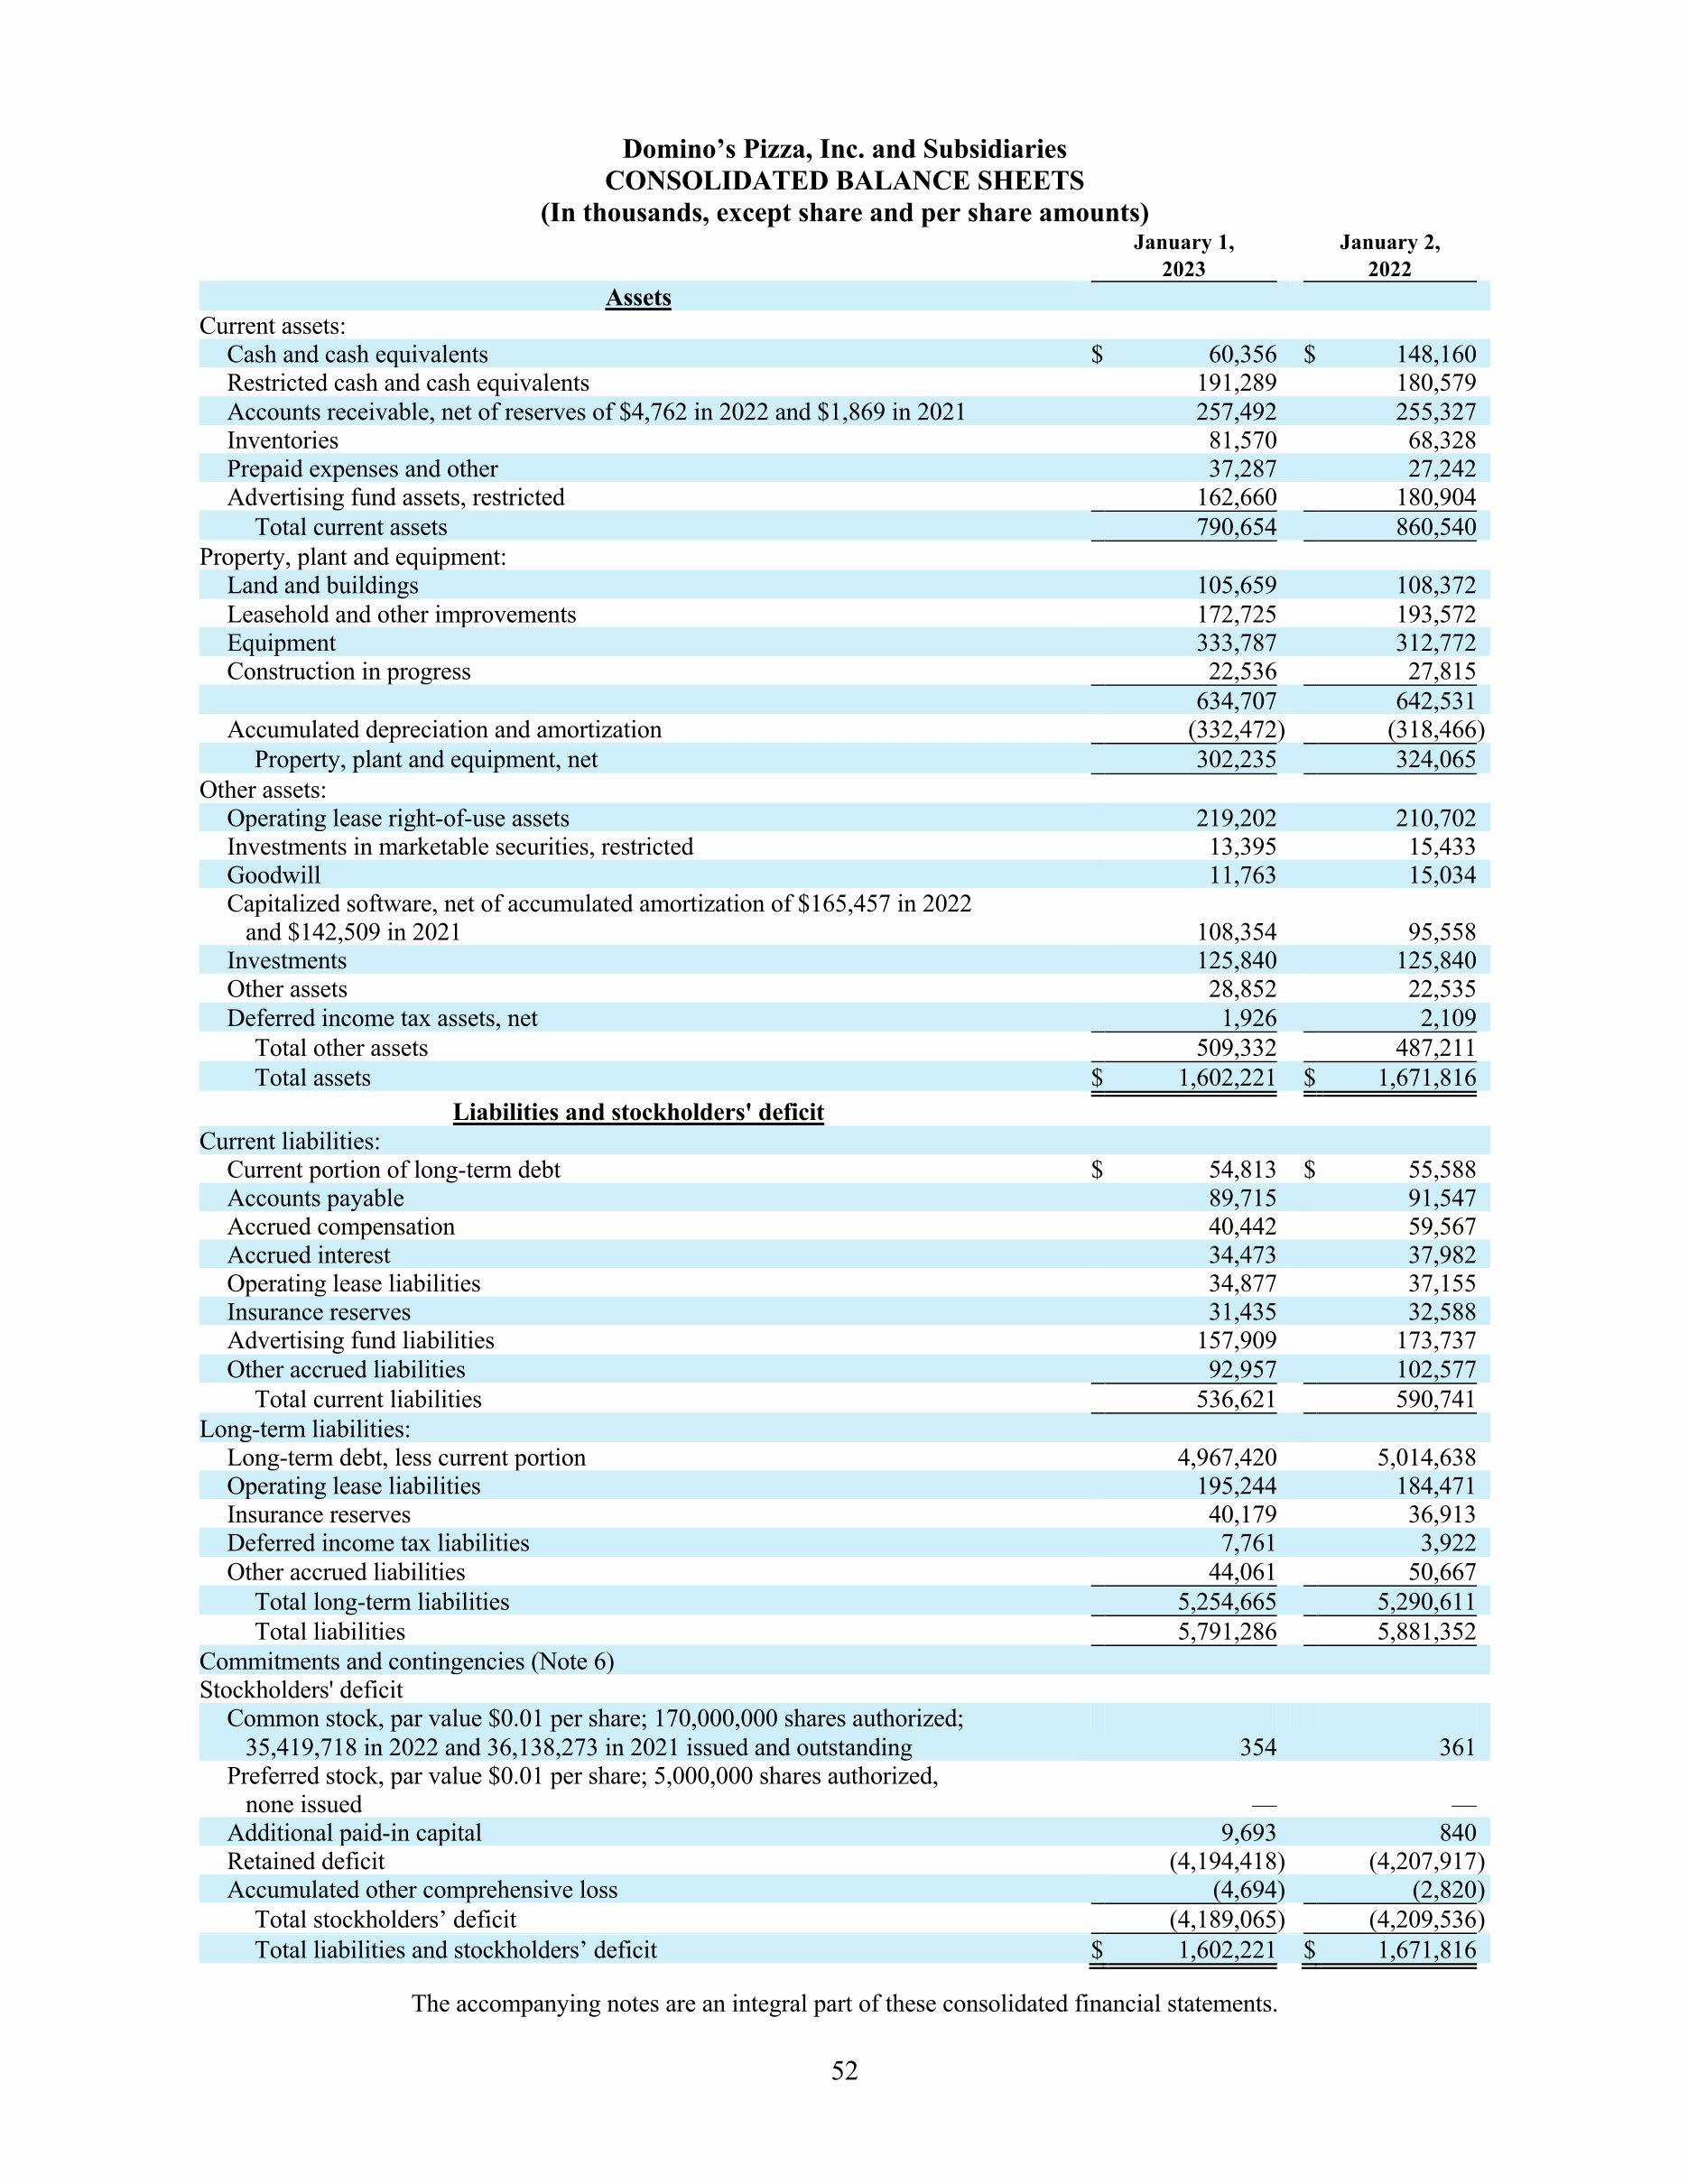

***2.2 Statement of cash flow***

Domino’s Pizza Quarterly Free cash flow history and growth rate from 2010 to 2023. Free cash flow can be defined as measure of financial performance calculated as operating cost flow minus capital expenditure.

Domino’s Pizza. Cash flow for the quarter ending September. 3 0 2023 was ,a year - over -Year

Domino’s Pizza. Cash flow for the 12 months ending September 30 2023 was year over year.

Domino’s Pizza Inc annual free cash flow for 2022 was $0.429 BL Hash 23.37% declined from 2021Domino’s Pizza Inc. Annual free cash flow for 2021 was $0.56 B. 11.8 % increase from 2020

Domino’s Pizza Inc Annual free cash flow for 2020 Whose $0.504 B a 19.02 % increase from 2029. 19.

Domino’s pizza financial Ratios for Analysis 2023

Year Current 2022

P/FCF Ratio 27.35 31.60

P/OCF Ratio 22.72 25.80

EV/Sales Ratio 3.99 3.80

EV/EBITDA Ratio 19.51 20.28

Current ratio= current assets/current liability

=790,654/536,621

=1.47

Quick ratio =current assets- inventories/Current liabilities

=790,654-81,570/536,621

=1.32

Cash ratio=cash/current liabilities

=251,645/536,621

=0.47

**2.3 Market analysis**

With nearly a quarter of digital delivery order market share, the company has positioned themselves well to service rising consumer expectations. Going forward, we expect to see Domino’s concede share of digital delivery to 3rd party apps as delivery revenues in other food categories outpace pizza. But as the digital delivery pie grows in size, we don’t expect this to have a negative impact on Domino’s. By offering quick delivery at a compelling price point, they’re positioned to be competitive.

When looking at the reasons consumers pass on ordering food, price comes in at the top of the list. Here is where the supposed opportunity lies in management’s fortressing strategy, though. By integrating the delivery process into the business, Domino’s stands to realize savings compared to other restaurants which are outsourcing delivery. On top of this, with their delivery times being as low as 16 minutes in some areas, they can offer a superior service (vs. delivery apps).

Connecting the dots shows an interesting picture where Domino’s is competing in two areas – pizza and delivery. Delivery growth has been driven by new third-party apps, and although Domino’s might concede share in the short run, we expect they’ll be able to offer an attractive value proposition keeping them competitive as the digital delivery pie grows. On the other hand, market share gains in pizza is key. With heavy investments in the delivery process compared to competitors, we believe Domino’s will continue to perform in the coming years.

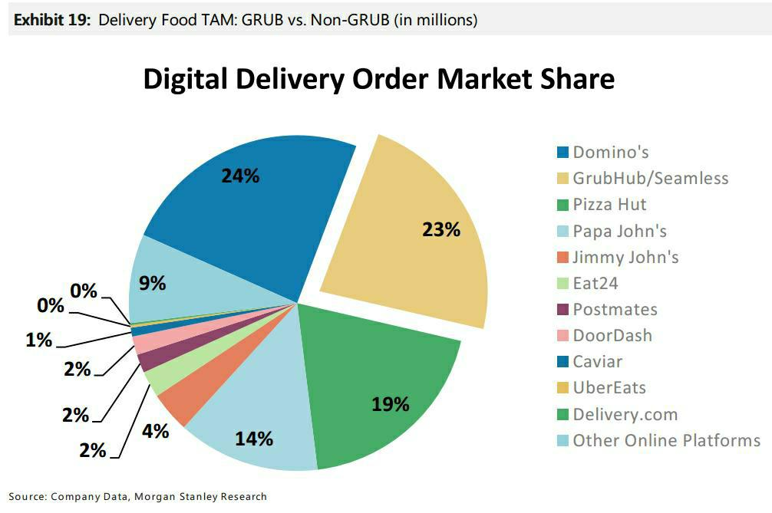

**CHAPTER 3**

**3.1 Domino’s leadership and their qualification**

**1. Richard Allison Jr. - CEO:**

- Qualifications: Richard Allison Jr. had been with Domino's Pizza for many years and held various leadership positions within the company. He had extensive experience in the foodservice industry and played a pivotal role in Domino's growth and digital innovation.

**2. Russell Weiner - COO and President of the Americas:**

- Qualifications: Russell Weiner had a background in marketing and held leadership positions in the marketing and advertising industry before joining Domino's. His expertise in marketing and branding contributed to Domino's success in the United States.

**3. Jeffrey D. Lawrence - CFO:**

- Qualifications: Jeffrey D. Lawrence brought financial expertise to his role as CFO. He likely had a background in finance, accounting, or related fields and had experience in financial management in various organizations.

***Domino’s corporate governance and process making***

Corporate Governance at Domino's Pizza typically involves the following key elements:

**1. Board of Directors:** The Board of Directors is responsible for overseeing the company's strategic direction and ensuring that it acts in the best interests of shareholders. The board members are typically composed of both executive (e.g., CEO) and non-executive directors. The board holds regular meetings to discuss and make decisions on various corporate matters.

**2. Board Committees:** Boards usually have committees that focus on specific areas of governance and oversight. Common committees include the audit committee, compensation committee, and nominating and governance committee. These committees have specific roles and responsibilities related to financial reporting, executive compensation, and board nominations.

**3. Shareholder Rights:** Corporate governance practices typically include mechanisms to protect shareholders' rights and interests. This may involve proxy voting, annual general meetings, and disclosure of financial and operational information to shareholders.

**4. Ethical and Legal Compliance:** Companies like Domino's Pizza have policies and procedures in place to ensure compliance with laws and regulations, as well as adherence to ethical standards. This includes financial reporting compliance (e.g., Sarbanes-Oxley Act) and ethical conduct codes.

**5. Decision-Making Process:** Decision-making processes at Domino's Pizza, like at many corporations, follow a structured approach. Major decisions, especially strategic ones, typically involve careful analysis, discussion, and board approval. The CEO and senior management team play a significant role in proposing and executing these decisions.

**6. Risk Management:** Corporate governance also includes risk management practices to identify, assess, and mitigate risks that could affect the company's operations, reputation, and financial performance

**7. Transparency and Reporting:** Companies are usually required to provide regular financial and operational reports to shareholders and regulatory bodies. These reports are essential for transparency and accountability.

**CHAPTER 4**

4.1 DOMINO’S SWOT ANALYSIS

**Strengths:**

**1. Global Brand Recognition:** Domino's is a well-known and established global brand with a strong presence in many countries, which gives it an advantage in terms of brand recognition.

**2. Digital Innovation:** Domino's has been a leader in using technology to enhance customer experience, including online and mobile ordering, real-time order tracking, and the Domino's app. This has helped streamline operations and improve customer satisfaction.

**3. Franchise Model:** The franchise model allows Domino's to expand rapidly with lower capital investment, as franchisees often provide the necessary funds for opening new stores.

**4. Efficient Supply Chain:** Domino's has invested heavily in building an efficient supply chain system, enabling it to maintain product quality and deliver pizzas quickly.

**Weaknesses:**

**1. Heavy Reliance on Pizza:** Domino's primary product is pizza, which makes it vulnerable to market fluctuations and changes in consumer preferences. Diversification into other food offerings is limited.

**2. Dependence on Delivery:** Domino's business model relies heavily on delivery services, which can be affected by factors like rising fuel costs and competition from third-party delivery services.

**3. Limited International Menu Adaptation:** In some markets, Domino's may struggle to adapt its menu to local tastes and preferences, limiting its appeal in certain regions.

**4. Competition:** The fast-food industry is highly competitive, with numerous rivals, including other pizza chains and quick-service restaurants. Staying ahead in the competitive landscape is a challenge.

**Opportunities:**

**1. Global Expansion:** Domino's has opportunities for further international expansion, particularly in emerging markets where there is a growing demand for fast-food options.

**2. Menu Diversification:** Expanding the menu to include more diverse offerings, such as pasta, sandwiches, or healthier options, could attract a broader customer base.

**3. Sustainability Initiatives:** The trend toward sustainable and eco-friendly practices in the food industry presents opportunities for Domino's to adopt more environmentally responsible practices.

**4. Partnerships and Alliances:** Collaborating with third-party delivery services or other brands can help Domino's reach more customers and expand its market presence.

***Threats:***

**1. Competition:** Intense competition from other pizza chains, local pizzerias, and fast-food restaurants can erode market share and profitability.

**2. Rising Costs:** Inflation, labor costs, and supply chain disruptions can lead to rising operating costs, potentially impacting profit margins.

**3. Health Concerns:** Growing health consciousness among consumers may lead to a decline in demand for fast food, including pizza.

**4. Regulatory Changes:** Changes in regulations related to food safety, labor practices, or marketing can affect how Domino's operates and its costs.

**5. Economic Downturn:** Economic recessions or downturns can lead to reduced consumer spending on dining out, affecting Domino's sales.

**4.2 Business model**

**About McKinsey 7s mode**

McKinsey 7 s model Framework is management model development by the business consultants Robert H Waterman, Jr and Tom Peters in 1980. This was strategic vision for groups to include business units and teams this includes the following 7 s

* Strategy,
* Structure.
* Systems
* shared values
* Skills
* Style
* staff.

***7 s model in domino’s pizza***

**Strategy:** As a business strategy domino’s operates internationally with franchise model . Franchise have the alright stop operate or build the store of the company in a region .The company also offers formal training to those who want to become franchise owner. The strategic direction and the overall business strategy for Domino’s Pizza are clearly defined and communicated to all the employees and stakeholders. This helps the organization manage performance, guide action and device different tactics that are aligned with the business strategy. Moreover, the business strategy, definition and communication also make operation for Domino’s Pizza more in transparent and allowing the responsibility and action of the company. Guiding behaviour for goal attainment, competitive process, changing consumer demands, flexibility and adaptability. These are comes under the strategy of the dominos company.

**Structure:** Domino’s Pizza has flatter organizational hierarchy that is supported by learning and progressive organization with lesser managerial level in between and more accesses to the senior management and leadership, the employees feel more secure and confident and also have higher access to the information. Moreover, the flatter hierarchy allows quicker decision making process for Domino’s Pizza and increase organizational commitment in the employees. Interdepartmental coordination is to better. Inter team dynamic department specific. Centralization vs decentralized .Domino’s Pizza has a hybrid structure between centralization and decentralization. Communication in Domino’s Pizza has a developed and intricate system for ensuring communication between employees.

**Systems:** Organizational systems in place Domino’s Pizza has defined and well defined systems in place to ensure that the business operations are managed effectively and that are. No conflict or disputes, this system of Domino’s Pizza are largely departmental in nature and include, for example, human resource management, finance, marketing, operations, sales, supply chain management, public relations management. Strategic leadership. Each dependent demarcated systems at Domino’s Pizza has specially designed tools and methods as control for evaluating performance and goal attainment. Domino’s Pizza continually evaluates it’s the system through the designed controls. Internal process for organizational alignment.

**Shared values:** The core values at Domino’s Pizza find and communicated to foster to creative and supportive organizational structure that will allow employees to perform optimally and enhance their motivation and organizational commitment. The core value Domino’s Pizza includes but. Are not limited to. Creativity, Honest. Transparency, Accountability, Trust, Quality. Heritage. Domino’s Pizza. Business also ensures that all its activity and operations are conducted with high ethical and moral standards, the defined and benchmarked against international criteria. Domino’s Pizza encourages. Cultural and celebrate diversity. Domino’s Pizza ensures that all the jobs task controls are aligned with the core value that the company propagates.

**Style:** Domino’s Pizza has a participative leadership style. Through a participant leadership style, Domino’s Pizza is able to engage and involved its employees in decision making process and managerial decision . This allows the leadership to regularly interact with the employees and different managerial groups to identify any potential conflicts for resolution as well As for feedback regarding strategic and operation. Through its participative leadership, Domino’s Pizza is able to enhance employee motivation and increase organizational commitment and ownership amongst employees. As well as other stakeholders .Domino’s Pizza have cooperation versus competition internally Term vs groups.

**Staff:** Domino’s Pizza has a sufficient number of employees employed across global operations. Employees for different jobs, roles and positions are hired internally as well as externally depending on the urgency and the skill level required based on this. It is seen that Domino’s Pizza has employees who are skilled as per the requirement of their job roles and position. All the employees are given in house training to familiarize themselves with the company and its value external training. Along with in house training is provided for skill level enhancement. All jobs, roles and positions are designed to facilitate state the achievement of business goals and has such employees. Skill level at Domino’s Pizza is sufficient to achieve the business goals of the company .The Domino’s company have large number of employees .Dominos as well defined system for identifying the potential needs, capabilities and capacity for the organization.

**Skills:** Domino’s Pizza has commendable workforce with high skills and capacities. All the employees are recruited based on their merit and qualifications. Domino’s Pizza pride itself on hiring and best professional and grooming them. Further, to facilitate growth and development. Employees skills versus task recruitment employees. Domino’s Pizza has defined task and job role under and train employee for skill level according with respect to those. The company ensures that all the job requirements are met and that employees have the sufficient skills to perform their respective jobs in accordance with the levels and culture, as well as business goals and strategy of the Domino’s Pizza. Domino’s Pizza house skill management and company competitive advantages

**Chapter 5**

**Summary of finding, suggestions and conclusion**

5.1 Summarize the key findings of

Investors have been cautious on Domino’s, as competition from third-party delivery apps heats up – shares of the global pizza chain are flat year-to-date.

Management continues focusing on their fortressing strategy in an effort to provide a compelling value proposition to customers.

Domino’s valuation, in-line with peers, is reasonable in our eyes – we expect shareholders invested for the long haul to realize healthy returns.

1 The 2022 and 2021 fi scale years each included 52 weeks and the 2020 fi scale year included 53 weeks.

2 Performance vs. fi scale years 2021, 2020 and 2019, respectively. International same store sales growth excludes changes in Foreign currency exchange rates. The 53rd week in fi scale 2020 had no impact on reported same store sales growth amounts.

3 Global Retail Sales represent sales by our Company-owned and franchised stores. Franchised store retail sales are reported To us by our franchisees and are not our revenues. International retail sales are reported in U.S. dollars.

4 Diluted Earnings Per Share, as adjusted, excludes items affecting comparability, as detailed in the respective Company

Earnings Release for each of 2021 and 2020. No items affected in 2022.

US QSR business is USD 272 Billion, and pizza is one category of that. So the US QSR Pizza category is worth USD 38 Billion (that’s like 14% market share).

The US QSR pizza category is primarily comprised of delivery, dine-in and carryout.

Delivery segment – USD 14 Billion (37% of US QSR Pizza market share)

Carryout segment – USD 23 Billion (60% of US QSR Pizza market share)

Dine-in category – USD 1 Billion (3% of US QSR Pizza market share)

Four companies control 65% of the US Pizza delivery market and 50% of the US Pizza carryout market.

Who are these four industry leaders? Domino’s, Pizza Hut, Papa John’s and Little Caesars Pizza.

How Domino’s make money?

So in this Domino’s Company Analysis we will look at the company’s five lines of business:

US Company-owned stores – The company have real estate, and they operate it completely.

US franchise royalties – The company allows someone to operate the store. The store owner gives royalty to the company. Each franchisee pays a 5.5% royalty fee on sales.

Supply chain – This is the cash cow for the company. The company helps the franchises with practically everything – raw material etc., and charges to the franchises.

International franchise – This is the same as running franchises in the USA – just that these franchises are outside the USA. Each franchisee pays a 3% royalty fee on sales.

US franchise advertising – Again paid by the franchises. The funds are primarily used to support the franchises (purchase media for advertising and support market research, field communications, public relations, commercial production, talent payments) and promote Domino’s brand. Stores in the United States currently contribute 6% of their sales to fund national marketing and advertising campaigns.

And from the above table, we can see that the franchise share is increasing and the company-owned stores’ share is reducing. So that’s what the company actually want.

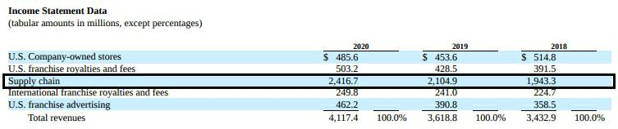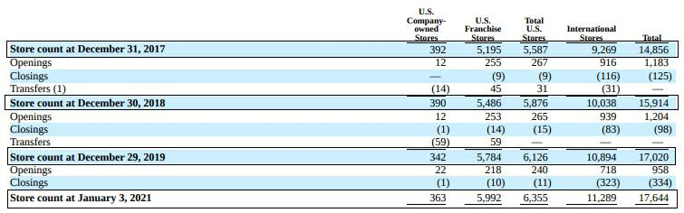As a result of the above – the company seem to be more interested in shutting/transferring owned stores.

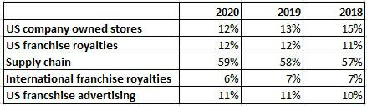

And India is one of the main International Market.

The top 10 markets outside the USA contribute to 65% of the International Franchisees.

**Learning experience:**

Friendly, courteous, helpful and team player behaviours. Great communication skills. The ability to maintain our high standards of quality, service delivery and cleanliness. High energy levels to “sell more pizza, and have more fun”Domino’s is focused on doing the right thing for pizza lovers, customers, team members and franchisees alike. We believe in providing opportunity, inclusion and diversity, giving back in the communities we serve, building a sustainable environment, and responsible sourcing

Offers delivery, carry-out, and dine-in options. Offers a wide range of pizza toppings and crust options. Has a rewards program that offers free pizzas

**Conclusions:**

Domino’s is known for their best services. We can summarize the whole that Employee’s behaviour is the major factor, which influences the customer perception most about the pizza outlets while they are followed by environment, parking space, internal, and external factors. Domino’s commitment to home delivery pizzas has kept them up to the mark and at the same time kept a good customer loyalty.

**Bibliography**: <https://en.m.wikipediya.org>

[https://ir.dominos.com https://in.investing.com/equities/dominos-pizza-ukir-balance-sheet-](https://ir.dominos.comhttps:/in.investing.com/equities/dominos-pizza-ukir-balance-sheet-)

<https://finshiksha.com/dominos-company-analysis/>

<https://www.essay48.com/13522-Dominos-Pizza-Mckinsey-7s>

<https://en.m.wikipedia.org/wiki/Domino%27s>

<https://www.marketing91.com/swot-analysis-of-dominos/>